AgroSmart Hub: Integrated Digital Farm Commerce Platform

Submitted by

BHAVANI SHANKAR.S
(Reg.No: 23-CE-002)

Under the Guidance of
Dr. T.SHANMUGAVADIVU, M.C.A., Ph.D.
Assistant Professor, UG Department of Computer Science (SF)
A project report submitted to the
Nallamuthu Gounder Mahalingam College (Autonomous), Pollachi
Affiliated to Bharathiar University, Coimbatore
In partial fulfilment of the requirements for the award of the Degree of
BACHELOR OF COMPUTER SCIENCE

UG DEPARTMENT OF COMPUTER SCIENCE (SF)
NALLAMUTHU GOUNDER MAHALINGAM COLLEGE
(AUTONOMOUS)
(An ISO 9001:2015 Certified Institution)
(Accredited by NAAC with A++)
Pollachi-642 001
MARCH-2026

CERTIFICATE

CERTIFICATE- I

This is to certify that the project work entitled “AgroSmart Hub: Integrated Digital Farm Commerce Platform” is a bonafide record of the work done by BHAVANI SHANKAR.S (23-CE-002) doing III-B.Sc. Computer Science submitted to Nallamuthu Gounder Mahalingam College, affiliated to Bharathiar University in partial fulfilment of the requirements for the award of the degree of B.Sc. Computer Science under my supervision.

GUIDE HEAD OF THE DEPARTMENT

This is to certify that this is a bonafide record of the work submitted by

BHAVANI SHANKAR.S
(23-CE-002)

For External Viva-voce examinations held on…………………………….

INTERNAL EXAMINER EXTERNAL EXAMINER

CERTIFICATE- II

This is to certify that the project work entitled “AgroSmart Hub: Integrated Digital Farm Commerce Platform” is the original work done by BHAVANI SHANKAR.S (23-CE-002) under my guidance.

Date:

Place: Pollachi Signature of the Guide

(Dr. T.SHANMUGAVADIVU, M.C.A, Ph.D.)

CERTIFICATE-III

This is to certify that the project work entitled “AgroSmart Hub: Integrated Digital Farm Commerce Platform” is the original work done by me under the guidance of Dr.T.SHANMUGAVADIVU, M.C.A, Ph.D.

Date:

Place: Pollachi BHAVANI SHANKAR.S
(23-CE-002)

ACKNOWLEDGEMENT

ACKNOWLEDGEMENT

I express my sincere thanks to our president Dr.B.K. KRISHNARAJ VANAVARAYAR, NGM College, Pollachi for allowing me to learn in this prestigious institution.

I express my thanks to our principal Dr.R.MANICKA CHEZIAN M.Sc., M.S., Ph.D, for providing me with the facilities to undertake the project and being a source of encouragement to carry out the project.

I convey my wholehearted thanks to Dr. R. NANDHAKUMAR M.C.A, M. Phil., M.B.A., SET., Ph.D, Assistant Professor and Head, UG Department of Computer Science (SF), NGM College for his motivation and inspiration to carry out the project.

I extend gratitude towards my guide Dr. T.SHANMUGAVADIVU, M.C.A, Ph.D., Assistant Professor, UG Department of Computer Science (SF), who gave me obligatory information and priceless suggestions regarding the project and without whom the project would have not been a great success.

I am grateful to express my thanks to my parents, whose gracious encouragement allowed me to work with a clean mind and heart.

I also thank my friends, who have helped me in completing the project successfully.

CONTENTS

 | CONTENTS
S.NO | PARTICULARS | PAGE NO
 | ACKNOWLEDEGEMENT
 | SYNOPSIS
1 | INTRODUCTION
1.1 | OVERVIEW OF THE PROJECT
1.2 | DESCRIPTION OF MODULES
1.3 | SYSTEM SPECIFICATION
 | 1.3.1 HARDWARE SPECIFICATION
 | 1.3.2 SOFTWARE SPECIFICATION
1.4 | SOFTWARE FEATURES
 | 1.4.1 FRONT END
 | 1.4.2 BACK END
2 | SYSTEM STUDY
2.1 | EXISTING SYSTEM
 | 2.1.1 DRAWBACKS OF EXISTING SYSTEM
2.2 | PROPOSED SYSTEM
 | 2.2.1 ADVANATAGES OF PROPOSED SYSTEM
3 | SYSTEM DESIGN AND DEVELOPMENT
3.1 | INPUT DESIGN
3.2 | DATABASE DESIGN
 | 3.2.1 TABLE DESIGN
 | 3.2.2 E-R DIAGRAM
 | 3.2.3 DATAFLOW DIAGRAM
3.3 | CODE DESIGN

3.4 | OUTPUT DESIGN
4 | SYSTEM TESTING AND IMPLEMENTATION
4.1 | SYSTEM TESTING
4.2 | TEST CASE
4.3 | SYSTEM IMPLEMENTATION
4.4 | SYSTEM MAINTENANCE
5 | CONCLUSION
6 | SCOPE FOR FUTURE ENHANCEMENT
7 | BIBILIOGRAPHY
8 | APPENDIX
 | A. SAMPLE SCREEN AND REPORTS
 | B. SAMPLE CODING

SYNOPSIS

INTRODUCTION

1. INTRODUCTION

1.1 OVERVIEW OF THE PROJECT

Agro Smart Hub is a web-based platform developed to make the buying and selling of agricultural products easier and more efficient. The main objective of this project is to provide an online marketplace where customers can browse different agricultural products, check their prices, and purchase them conveniently through a digital system.
In the traditional agricultural market, customers usually need to visit physical markets to buy products, which can be time-consuming and sometimes inconvenient. Agro Smart Hub solves this problem by allowing users to access products online, place orders, and receive order confirmation through a simple web interface. The system helps improve accessibility and saves time for customers.
The application allows users to register, log in, view available products, add items to a cart, and place orders. Once the order is completed, the system generates a digital receipt showing the order details such as product name, quantity, price, and total amount. This project demonstrates how web technology can be used to create an efficient and user-friendly agricultural product management system.

MODULES
- Admin Login Module
- User Login Module
- Supplier and Customer Profiles
- Product and Stock Management
- Order Monitoring Module

1.2 MODULE DESCRIPTION

• Admin Login Module
The Admin Login Module allows the administrator to access the system securely with special privileges. The admin manages the overall activities of the Agro Smart Hub platform. Through this module, the admin can manage users, update product details, monitor orders, and maintain the system database.

• User Login Module
The User Login Module allows customers to register and log into the Agro Smart Hub system using their credentials. After logging in, users can view available agricultural products, add items to the cart, and place orders. This module ensures that only authorized users can access their accounts and perform actions in the system.

• Supplier and Customer Profiles
This module stores and manages the information of suppliers and customers. Supplier profiles include details about farmers or product providers, while customer profiles contain information such as name, address, and contact details. Maintaining these profiles helps in managing product supply and customer orders efficiently.

• Product and Stock Management
The Product and Stock Management module maintains the agricultural products available in the system. It records product details such as product name, price, and quantity. The system automatically updates stock levels when products are added or purchased, ensuring accurate inventory management.

• Order Monitoring Module
This module tracks all orders placed by customers. It records order details such as product name, quantity, price, and delivery information. The system processes the order and generates a digital receipt for the customer after successful purchase.
1.3 SOFTWARE SPECIFICATION
1.3.1 Hardware Specification
Processor : Intel Core i3 or above
RAM : 8 GB
Hard Disk : 500 GB
Monitor : Color Monitor
Printer : Laser Printer

1.3.2 Software Specification
Operating System : Windows / Platform Independent
Front End : HTML, CSS, JavaScript, Bootstrap
Back End : Python
Database : MySQL Server

1.4 SOFTWARE FEATURES

1.4.1 FRONT END

The front end of the Agro Smart Hub project is designed to provide an interactive and user-friendly interface for users. It is developed using HTML, CSS, JavaScript, and Bootstrap. HTML is used to create the basic structure of web pages, while CSS is used to design and style the layout of the website. JavaScript is used to add dynamic behavior and improve user interaction within the system.
Bootstrap is used to create responsive and visually appealing web pages that can work on different devices such as computers, tablets, and mobile phones. The front end allows users to easily register, log in, view available agricultural products, add items to the cart, and place orders. It ensures smooth navigation and improves the overall user experience of the Agro Smart Hub platform.

1.4.2 BACK END

The back end of the Agro Smart Hub project is developed using Python. The back end is responsible for handling the core functionality of the system such as processing user requests, managing product information, handling user authentication, and processing customer orders.
The backend communicates with the MySQL database to store and retrieve important data such as user details, product information, stock details, and order records. It ensures that all operations such as login verification, product updates, and order processing are performed securely and efficiently. The backend plays an important role in maintaining the reliability and smooth functioning of the Agro Smart Hub system.

SYSTEM STUDY

2. SYSTEM STUDY

2.1 EXISTING SYSTEM
In the existing system, the process of buying and selling agricultural products is mostly done manually. Product details, customer details, sales details, and stock information are usually maintained using paper records or individual registers. Farmers and buyers depend on local markets and middlemen for selling and purchasing agricultural products.
This manual system is prone to many problems because maintaining records manually does not ensure accuracy and reliability. It becomes difficult to track product availability, customer details, and daily sales records efficiently. The existing system has the following drawbacks.
2.1.1 DRAWBACKS OF EXISTING SYSTEM
- The existing system has very limited security measures.
- Maintaining records manually may lead to data loss and errors.
- The system does not generate proper reports for management decisions.
- Daily sales and product information are difficult to track.
- A large amount of time and manual effort is required.

2.2 PROPOSED SYSTEM
The proposed system Agro Smart Hub is designed to provide an online platform where farmers can sell their agricultural products directly to buyers. The system maintains product details, customer details, order details, and stock information in a digital database.
Through this system, users can easily view available products, place orders, and receive order details through the web application. The system reduces manual work, improves accuracy, and saves time compared to the traditional paper-based method.
2.2.1 ADVANTAGES OF PROPOSED SYSTEM
- Direct communication between farmers and buyers without middlemen.
- Product prices are displayed clearly, ensuring transparency.
- Farmers can reach buyers from different locations through the online platform.
- Secure login system for farmers and buyers.
- All records such as users, products, and orders are stored digitally.
- Reports and order details can be generated easily.
- Time and cost required for manual processes are reduced.

SYSTEM DESIGN AND
DEVELOPMENT

3. SYSTEM DESIGN AND DEVELOPMENT
System design is the process of planning a new system to improve or completely replace the existing system. The main purpose of the design phase is to move from the problem domain to the solution domain. The design of the system is a critical aspect that affects the quality and performance of the software. System design is also called top-level design.
During the design phase, the logical aspects of the system are converted into physical aspects of the system. It defines how the system will operate in terms of hardware, software, data, and user interaction.
The major components of system design are:
- Input Design
- Database Design
- Code Design
- Output Design
3.1 INPUT DESIGN
Input design is the process of converting user-oriented inputs into a computer-based format. The main objective of input design is to make data entry easy, logical, and free from errors. Proper input design helps in controlling errors that may occur during data entry.
The quality of input directly affects the quality of the system output. Therefore, input forms should be simple, user-friendly, and well-structured. Validation techniques are also used to ensure that only correct and complete data is entered into the system.
3.2 DATABASE DESIGN
A database is a collection of interrelated data stored with minimum redundancy so that it can serve multiple users quickly and efficiently. During database design, the system analyst studies the data requirements to determine which data should be stored in permanent storage devices.
The analyst is responsible for designing a control system that prevents unauthorized access and tampering with the data stored in the computer.
Database design involves the creation of tables. Tables are represented in the physical database as stored files, and each table has its own independent existence. A table consists of rows and columns.
- Each column represents a piece of information called a field.
- A set of fields forms a record.
- A record contains complete information about a specific item.
A database is an essential component of an information system, especially in business-oriented applications. Therefore, database design plays an important role in system development.
In the conceptual database design phase, a data model is created without considering physical storage details. This model is developed based on the system requirements.
In the logical database design phase, the data model is structured according to a specific data model such as relational databases, but it is still independent of a particular Database Management System (DBMS). This phase focuses on defining tables, relationships, and constraints required for the system.
3.2.1TABLE DESIGN
1. ADMIN TABLE
Admin → password only
Field Name | Data Type | Size | Description
admin_id | INT | 10 | Admin unique ID
password | VARCHAR | 200 | Admin login password

2. USERS TABLE
Field Name | Data Type | Size | Description
user_id | INT | 10 | User ID
username | VARCHAR | 50 | Login username
password | VARCHAR | 200 | Login password
phone | VARCHAR | 15 | Phone number
role | ENUM | Farmer,buyer | User role
created_at | TIMESTAMP | - | Account created time
updated_at | TIMESTAMP | - | Last profile update

3. PRODUCTS TABLE
Field Name | Data Type | Size | Description
product_id | INT | 10 | Product ID
farmer_id | INT | 10 | Farmer user ID
product_name | VARCHAR | 100 | Product name
product description | VARCHAR | 100 | Product description
image | VARCHAR | 250 | Product image
price | DECIMAL | 10,2 | Price
quantity | INT | 10 | Available quantity
status | ENUM | Approved, Rejected | Admin approval
created_at | TIMESTAMP | - | Product created
updated_at | TIMESTAMP | - | Product updated

4. CART TABLE
Field Name | Data Type | Size | Description
cart_id | INT | 10 | Cart ID
buyer_id | INT | 10 | Buyer ID
Product_name | VARCHAR | 100 | Product name
product_id | INT | 10 | Product ID
quantity | INT | 10 | Selected quantity
price | DECIMAL | 10,2 | Price
created_at | TIMESTAMP | - | Added to cart
updated_at | TIMESTAMP | - | Cart modified

5. ORDERS TABLE
Field Name | Data Type | Size | Description
order_id | INT | 10 | Order ID
user_id | INT | 10 | Buyer ID
total_amount | DECIMAL | 10,2 | Order amount
address | TEXT | 100 | Delivery address
phone | VARCHAR | 15 | Contact number
status | VARCHAR | 20 | Order status
created_at | TIMESTAMP | - | Order placed time
updated_at | TIMESTAMP | - | Order updated

6. ORDER ITEMS TABLE
Field Name | Data Type | Size | Description
order_item_id | INT | 10 | Item ID
order_id | INT | 10 | Order ID
product_id | INT | 10 | Product ID
product_name | VARCHAR | 100 | Product name
quantity | INT | 10 | Quantity
price | DECIMAL | 10,20 | Price
created_at | TIMESTAMP | - | Item created
updated_at | TIMESTAMP | - | Item updated

3.2.1 ER DIAGRAM

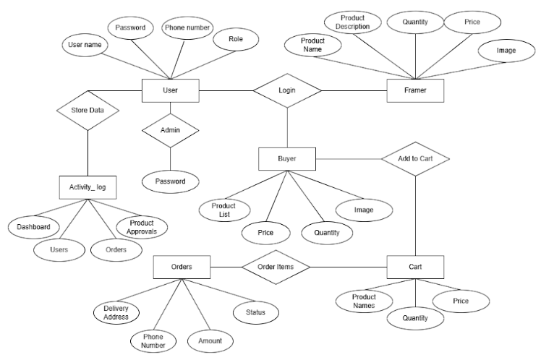

3.2.1 DATA FLOW DIAGRAM
Level 0

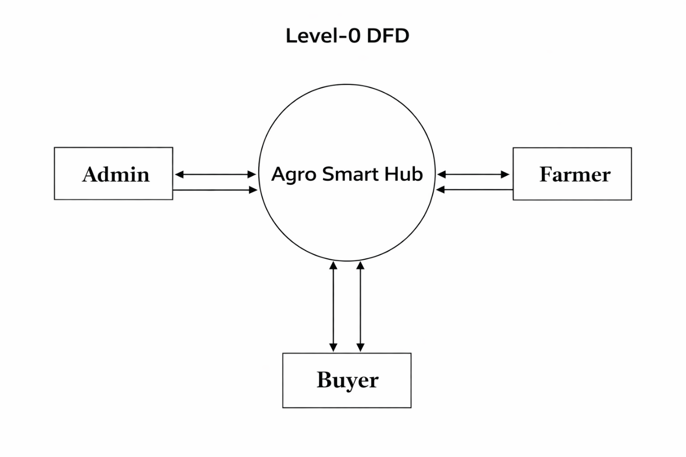

Level 1

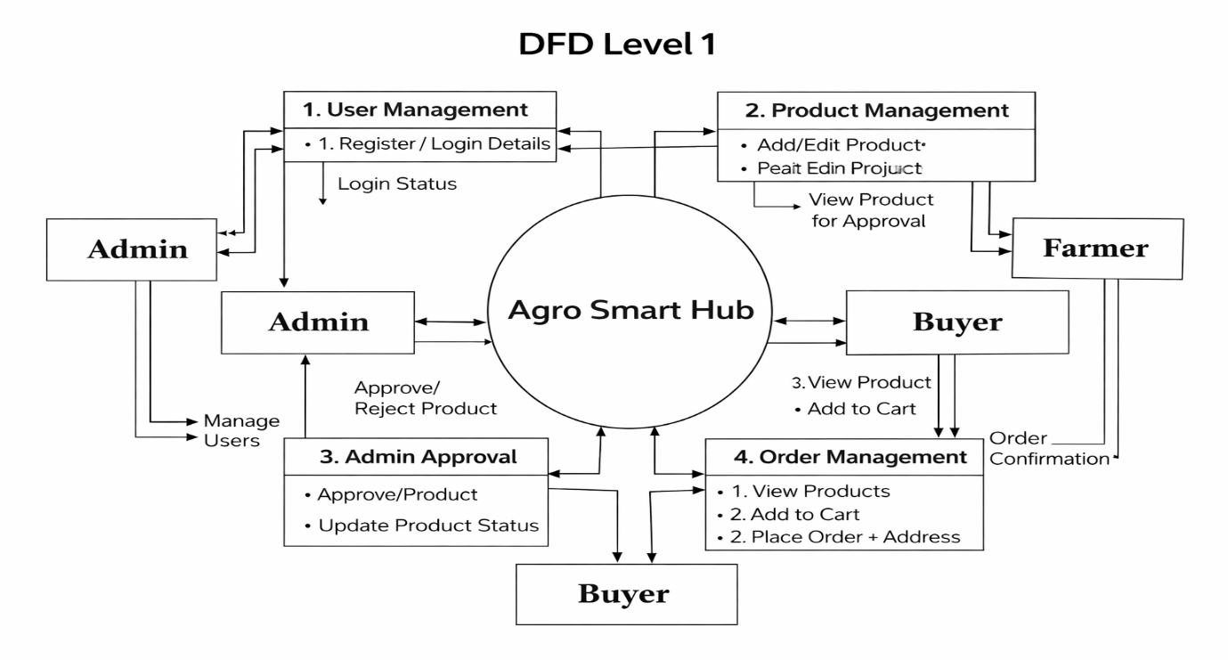

LEVEL 2

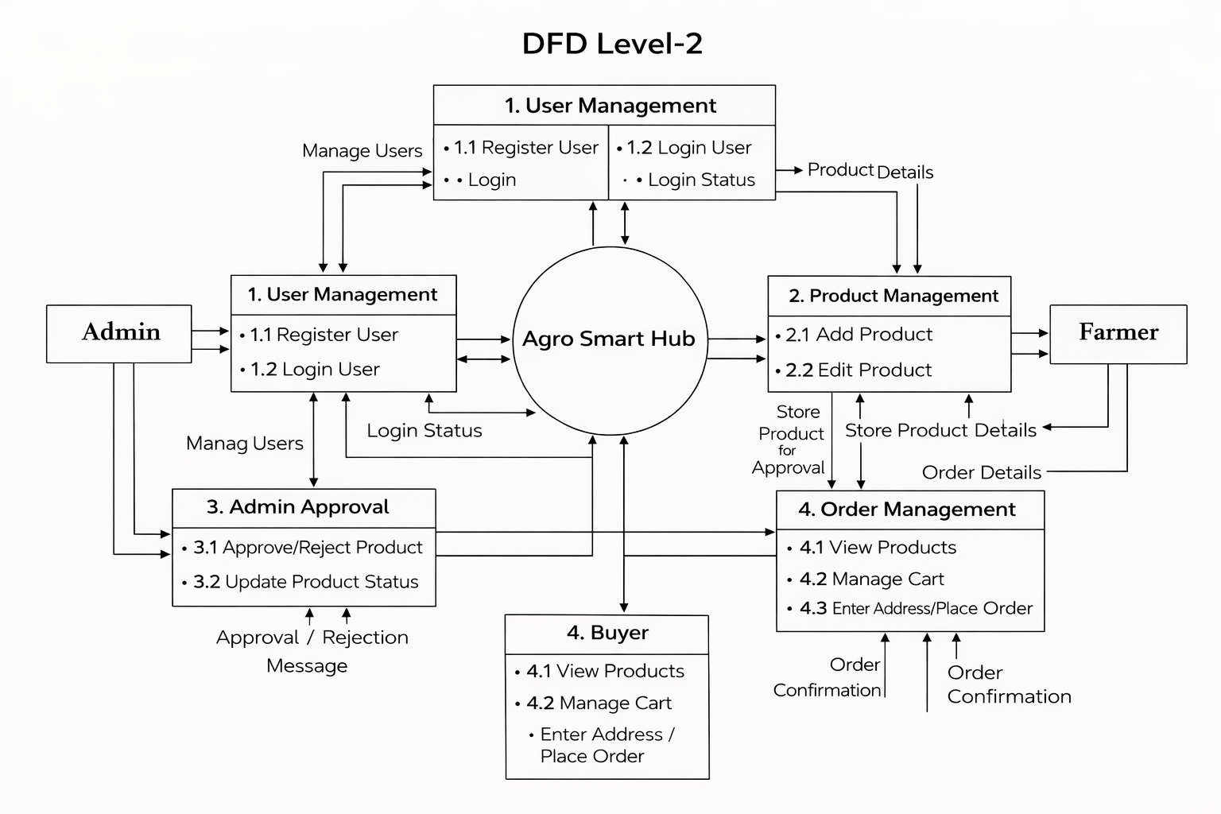

3.3 CODE DESIGN
Code design refers to the detailed plan for how the software’s source code will be structured, written, and organized to meet the functional and non-functional requirements of the project. It defines the architecture, modules, classes, functions, data flow, and interactions within the system.
The main purpose of code design is to provide a clear guideline for developers during the implementation phase. It helps maintain consistency in coding standards and ensures that the system is scalable, maintainable, and efficient.
Code design also focuses on dividing the system into smaller modules so that each module performs a specific task. This modular approach improves code readability, simplifies debugging, and makes future modifications easier. Proper code design ensures that the software is reliable and performs efficiently.

3.4 OUTPUT DESIGN
Output design is an important part of system design. The main objective of output design is to present the processed information to users in a clear and understandable format. Outputs from computer systems are mainly used to communicate the results of processing to the users.
The output should be well organized and properly formatted so that it contains all the necessary information without any complexity. A good output design ensures that the information is accurate, meaningful, and easy to interpret.
Output design determines how the information will be displayed on the screen for immediate use and also how it will be generated as printed reports or hard copies. A quality output is one that meets the requirements of the end users and presents the information clearly.
Efficient and well-designed outputs improve the usability of the system and help users make better decisions based on the information provided.

SYSTEM TESTING AND
IMPEMENTATION

4.SYSTEM TESTING AND IMPLEMENTATION

4.1System Testing
System testing is the process of testing the complete Agro Smart Hub system to ensure that all the modules work correctly together. It is performed after the development of the system and before it is delivered to users.
In this stage, the entire application is tested, including user registration, login, farmer product upload, product display, and buyer purchase process. The main purpose of system testing is to ensure that the system works according to the requirements and provides correct results.
System testing helps to identify errors, bugs, and performance problems in the system. It also checks whether the system works properly in different conditions. This testing is carried out in an environment similar to the real working environment so that the system reliability and performance can be verified before the system is used by farmers and buyers.

1.UnitTesting
Unit testing is the process of testing individual modules of the Agro Smart Hub system separately. For example, testing the login module, registration module, and product upload module individually to ensure they work correctly.
2.IntegrationTesting
Integration testing checks whether different modules of the system work together properly. For example, verifying that the farmer product upload module correctly stores product details and displays them to buyers.
3.SystemTesting
System testing is done to test the complete Agro Smart Hub application as a whole. It ensures that all features such as adding products, viewing products, and purchasing products function correctly.
4.FunctionalTesting
Functional testing checks whether each function of the system works according to the project requirements. For example, verifying that farmers can add products and buyers can view and purchase them successfully.
5.PerformanceTesting
Performance testing evaluates the speed and responsiveness of the system. It ensures that the system works smoothly when multiple users access the platform at the same time.

4.2 TEST CASES
Test Case 1 – Login Function
This test case checks whether the login module works correctly. The user enters a valid username and password to access the system. If the entered details are correct, the system should allow the user to log in successfully. If incorrect details are entered, the system should display an error message.

Test Case 2 – Product Entry
This test case verifies whether the system allows the user to add a new product. The user enters the product name, price, quantity, and category. The system should store the product details correctly in the database.

Test Case 3 – Product Update
This test case checks whether the user can update the details of an existing product. The user selects a product and changes the price or quantity. The system should update the product information successfully in the database.

Test Case 4 – Product Delete
This test case verifies whether the system allows the user to delete a product. When the user selects a product and clicks the delete option, the system should remove the product details from the database.

Test Case 5 – Customer Details
This test case checks whether customer information can be added correctly. The user enters customer name, contact number, and address. The system should save the details without errors.

Test Case 6 – Input Validation
This test case verifies whether the system validates the input fields properly. For example, the name field should accept only characters, and numeric fields should accept only numbers. If incorrect data is entered, the system should display an error message.

Test Case 7 – Report Generation
This test case checks whether the system can generate reports. When the user requests a report, the system should display the correct product or sales information.

4.3 SYSTEM IMPLEMENTATION
System implementation is the stage in the project where the designed system is converted into a fully working system. It is one of the most important phases in system development because it ensures that the new system operates effectively and efficiently.
During the implementation stage, the developed software is installed and tested in the real working environment. The main objective of this phase is to ensure that the system functions correctly and meets the requirements of the users.
The implementation process includes several important activities such as testing the developed program with sample data, identifying and correcting errors, and making necessary modifications based on user requirements. This stage also involves training the users so that they can operate the system easily and effectively.
The main steps involved in system implementation are:
- Testing the developed program with sample data
- Detecting and correcting errors
- Making necessary changes based on user requirements
- Training users to operate the system

4.4 SYSTEM MAINTENANCE
System maintenance is the final phase of the system development life cycle. It refers to the activities performed after the system has been implemented and is being used by users. The main purpose of maintenance is to ensure that the system continues to operate efficiently and effectively over time.
During system usage, some errors or issues may be identified. These problems must be corrected to maintain the proper functioning of the system. Maintenance also involves updating the system to adapt to changes in technology, user requirements, or the working environment.
System maintenance may include correcting errors, improving system performance, and adding new features when required. Regular maintenance helps the system remain reliable, secure, and useful for a long period of time.

CONCLUSION

CONCLUSION

The Agro Smart Hub system has been successfully designed and developed to simplify the management of agricultural products and related information. The system helps in maintaining product details, customer information, stock management, and sales records in an organized manner. By using this system, manual work can be reduced and data can be stored and managed efficiently.
The developed system provides a user-friendly interface that allows users to easily add, update, delete, and view product information. The system also ensures accuracy and reliability in managing agricultural data. It improves efficiency by reducing errors that usually occur in manual record keeping.
Overall, the Agro Smart Hub system helps farmers and users manage agricultural product information effectively. The system saves time, improves data management, and provides better support for decision-making in agricultural activities.

SCOPE FOR FUTURE
ENHANCEMENT

Scope for Future Enhancement
The Agro Smart Hub system can be further improved by adding new features and technologies in the future. These enhancements will help farmers and buyers use the system more effectively and improve the overall performance of the application.
1.Online Payment System
In the future, an online payment feature can be added so that buyers can pay for the products directly through the system using digital payment methods.
2.Mobile Application
A mobile application can be developed for Android or iOS so that farmers and buyers can easily access the platform from their smartphones.
3.Product Tracking System
A tracking feature can be introduced to allow buyers to track the delivery status of their purchased products.
4.Notification System
The system can send notifications to farmers when a buyer places an order and notify buyers about new products or offers.
5.Advanced Search and Filter Options
More advanced search and filtering options can be added so that buyers can easily find products based on category, price, or location.
6.Multi-Language Support
The system can support multiple languages so that farmers from different regions can use the application easily.
7.Rating and Review System
Buyers can provide ratings and reviews for the products and farmers, which will help other users make better purchasing decisions.

BIBLIOGRAPHY

BIBLIOGRAPHY
Referred Books
- Alan Forbes, “The Joy of PHP Programming: A Beginner’s Guide to Programming Interactive Web Applications with PHP and MySQL”, 5th Edition, Plum Island Media, 2019.
- Tom Butler & Kevin Yank, “PHP & MySQL Novice to Ninja”, 6th Edition, SitePoint, 2020.
- Lynn Beighley & Michael Morrison, “Head First PHP & MySQL”, 1st Edition, O’Reilly Media, 2018.
- Vikram Vaswani, “PHP: A Beginner’s Guide”, 5th Edition, McGraw-Hill Education, 2019.
- Robin Nixon, “Learning PHP, MySQL, JavaScript, & CSS: A Step-by-Step Guide to Creating Dynamic Websites”, 2nd Edition, O’Reilly Media, 2019.
REFERRED WEBSITES
- www.phptutorial.codepoint.net
- www.tuxradar.com/practicalphp
- www.makeuseof.com
- www.php.net
- www.mysql.com
- www.dbninja.com
- www.devmysql.com

APPENDIX

APPENDIX

A.Sample Screen and Reports

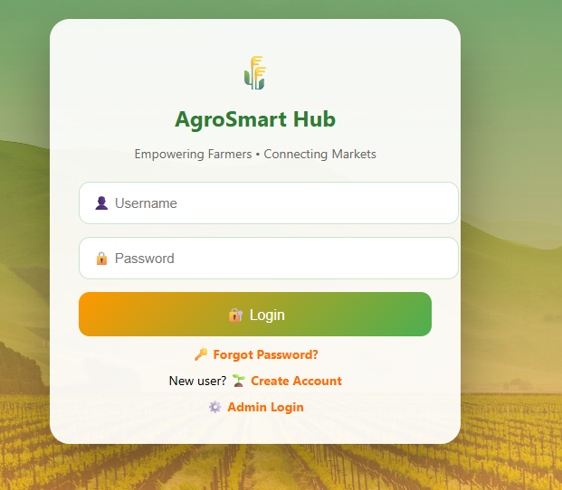

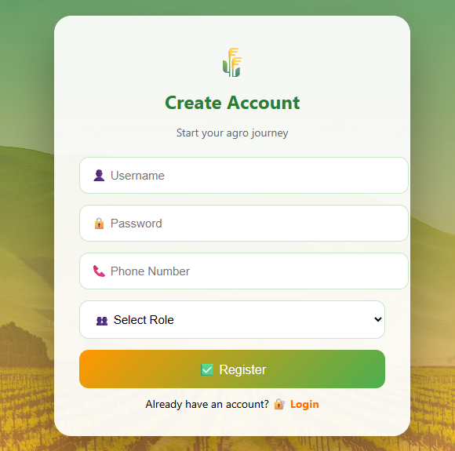

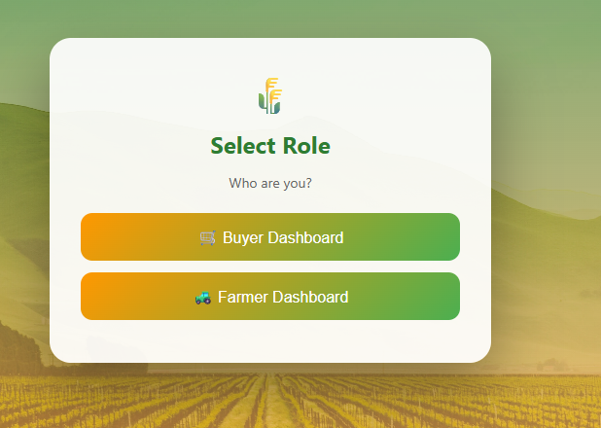

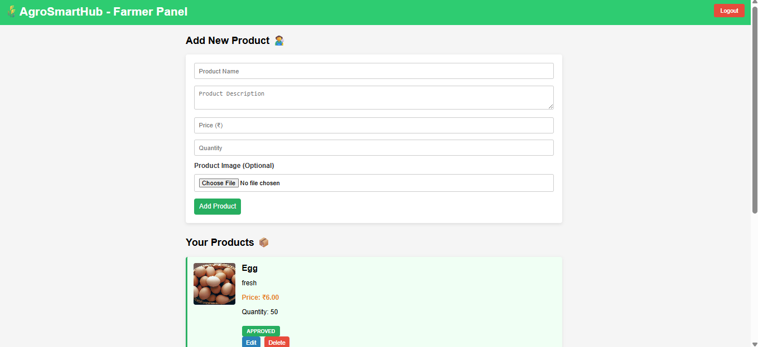

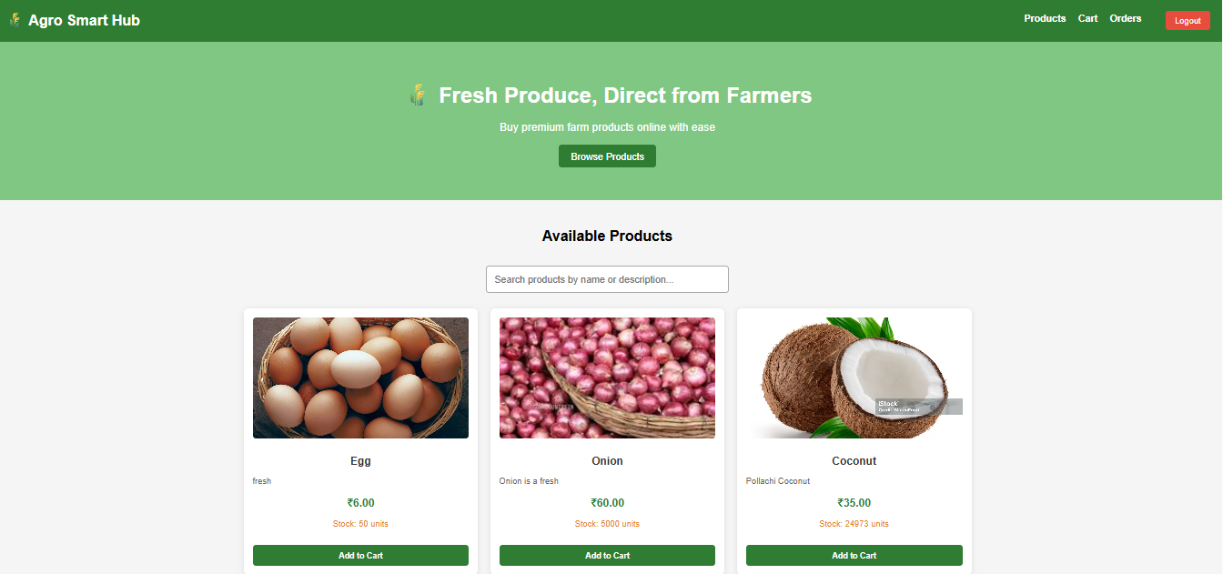

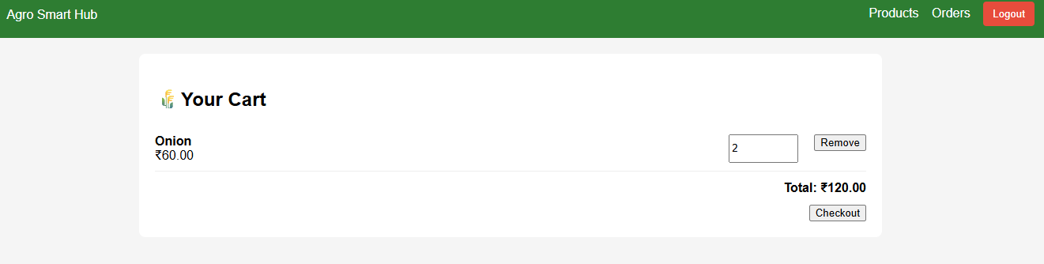

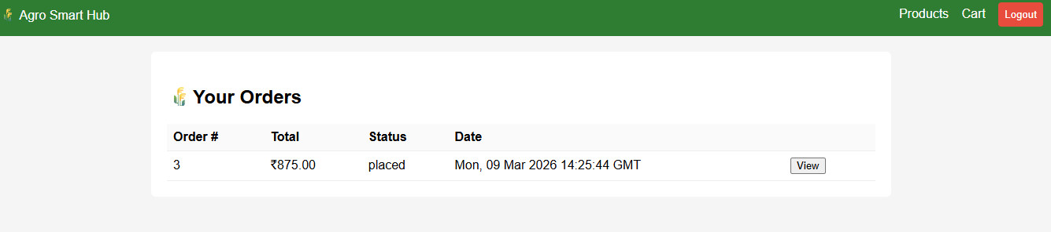

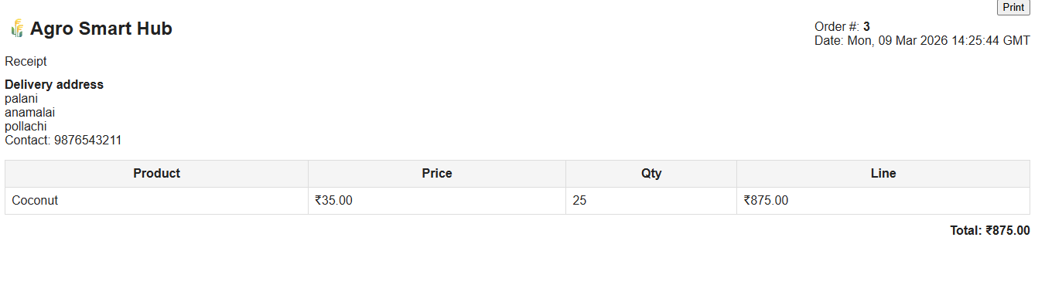



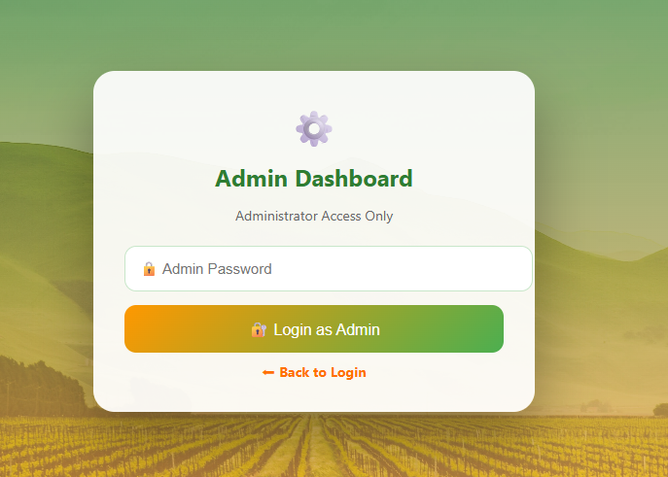

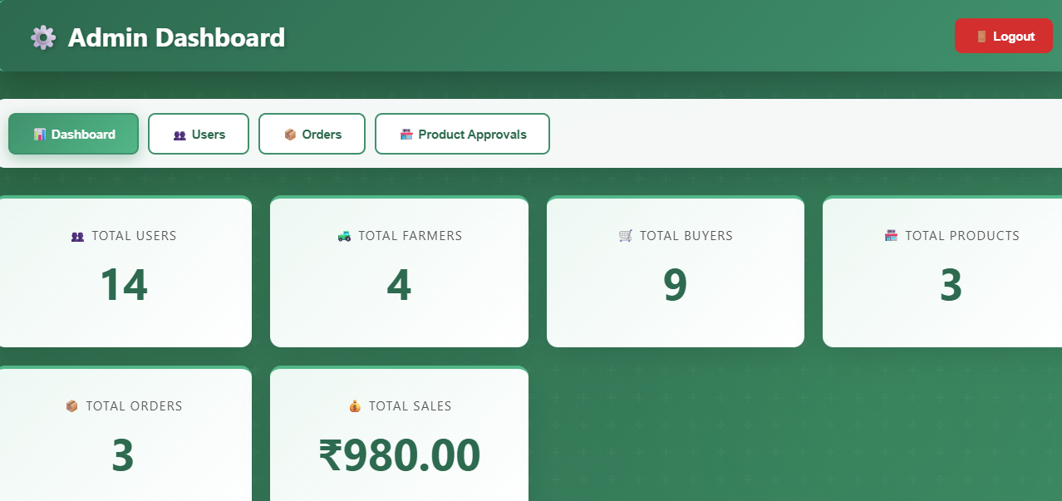

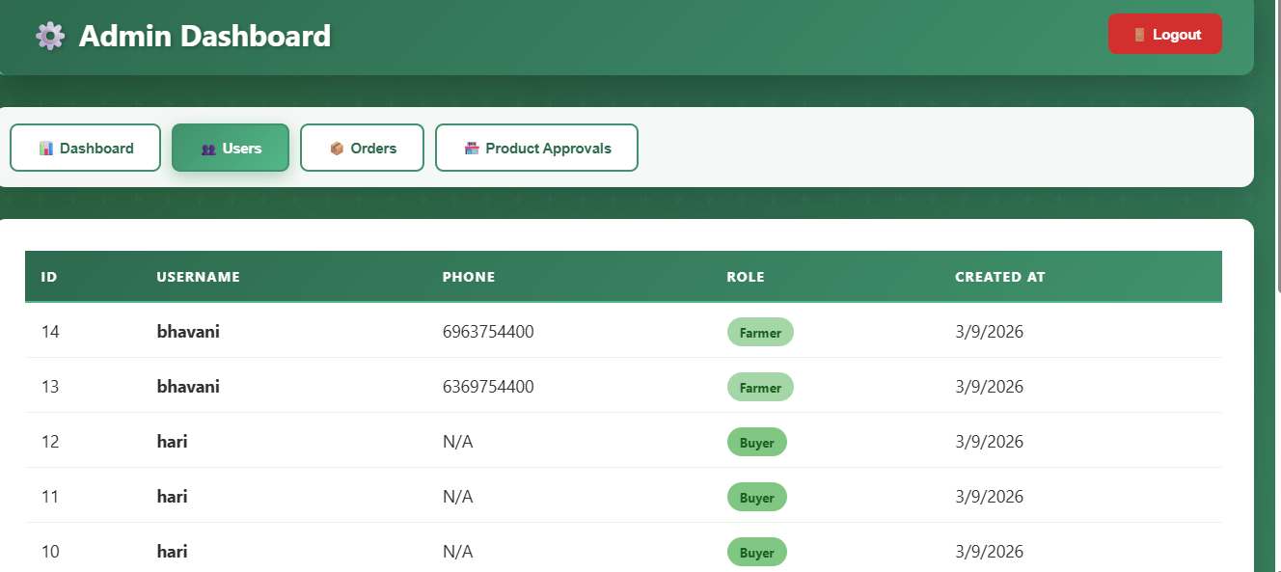

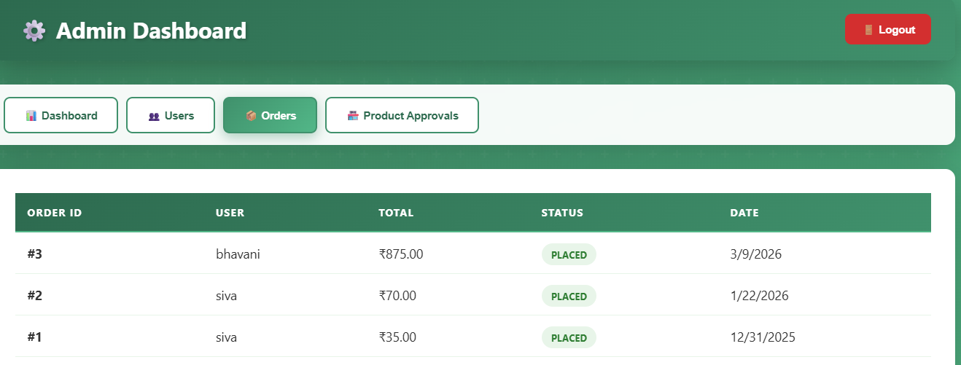

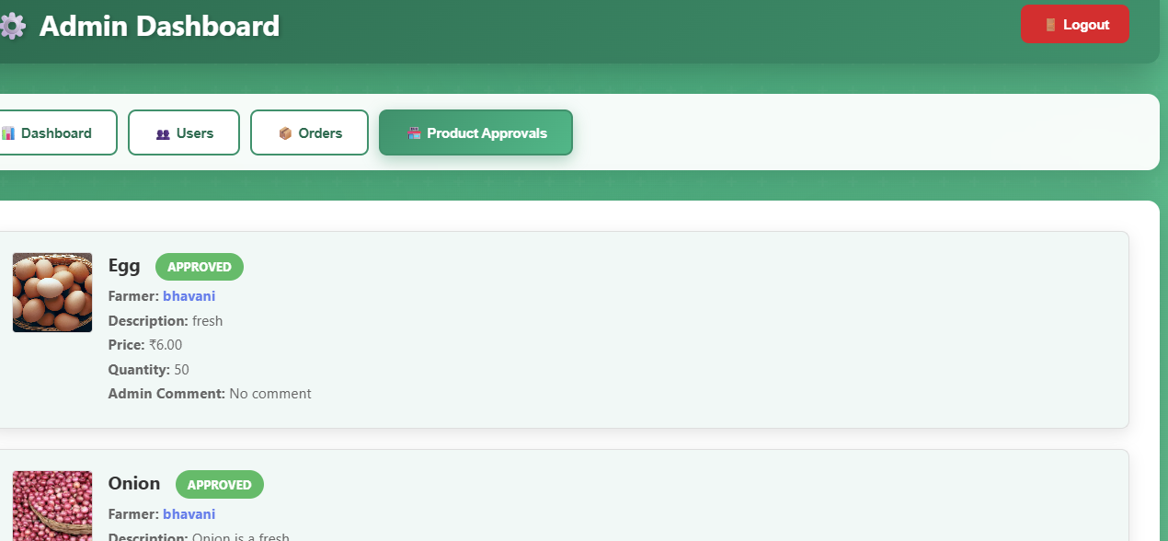

B.SAMPLE CODEING

HTML CODE:
<!DOCTYPE html>
<html lang="en">
<head>
<meta charset="UTF-8">
<meta name="viewport" content="width=device-width, initial-scale=1.0">
<title>Admin Dashboard - AgroSmart Hub</title>
<style>
* {
margin: 0;
padding: 0;
box-sizing: border-box;
}

body {
font-family: 'Segoe UI', Tahoma, Geneva, Verdana, sans-serif;
background: linear-gradient(135deg, #1e5128 0%, #2d6a4f 25%, #40916c 50%, #52b788 75%, #74c69d 100%);
background-attachment: fixed;
background-size: 400% 400%;
animation: agriGradient 15s ease infinite;
min-height: 100vh;
padding: 20px;
position: relative;
overflow-x: hidden;
}

body::before {
content: '';
position: fixed;
top: 0;
left: 0;
right: 0;
bottom: 0;
background-image:
radial-gradient(circle at 20% 50%, rgba(100, 200, 100, 0.1) 0%, transparent 50%),
radial-gradient(circle at 80% 80%, rgba(76, 175, 80, 0.1) 0%, transparent 50%),
url("data:image/svg+xml,%3Csvg width='60' height='60' viewBox='0 0 60 60' xmlns='http://www.w3.org/2000/svg'%3E%3Cg fill='none' fill-rule='evenodd'%3E%3Cg fill='%23ffffff' fill-opacity='0.03'%3E%3Cpath d='M36 34v-4h-2v4h-4v2h4v4h2v-4h4v-2h-4zm0-30V0h-2v4h-4v2h4v4h2V6h4V4h-4zM6 34v-4H4v4H0v2h4v4h2v-4h4v-2H6zM6 4V0H4v4H0v2h4v4h2V6h4V4H6z'/%3E%3C/g%3E%3C/g%3E%3C/svg%3E");
pointer-events: none;
z-index: -1;
}

@keyframes agriGradient {
0% { background-position: 0% 50%; }
50% { background-position: 100% 50%; }
100% { background-position: 0% 50%; }
}

.container {
max-width: 1400px;
margin: 0 auto;
}

.header {
background: linear-gradient(135deg, #2d6a4f 0%, #40916c 100%);
padding: 20px 30px;
border-radius: 12px;
box-shadow: 0 10px 40px rgba(0, 0, 0, 0.3);
display: flex;
justify-content: space-between;
align-items: center;
margin-bottom: 30px;
border-left: 5px solid #52b788;
backdrop-filter: blur(10px);
}

.header h1 {
color: #fff;
display: flex;
align-items: center;
gap: 10px;
font-size: 28px;
text-shadow: 2px 2px 4px rgba(0, 0, 0, 0.2);
}

.logout-btn {
padding: 10px 20px;
background: #d32f2f;
color: white;
border: none;
border-radius: 8px;
cursor: pointer;
font-weight: bold;
transition: 0.3s;
}

.logout-btn:hover {
background: #b71c1c;
transform: translateY(-2px);
}

.nav-tabs {
display: flex;
gap: 10px;
margin-bottom: 30px;
background: rgba(255, 255, 255, 0.95);
padding: 15px;
border-radius: 12px;
box-shadow: 0 10px 40px rgba(0, 0, 0, 0.2);
backdrop-filter: blur(10px);
}

.nav-btn {
padding: 12px 24px;
border: 2px solid #40916c;
background: white;
color: #2d6a4f;
border-radius: 8px;
cursor: pointer;
font-weight: bold;
transition: 0.3s;
}

.nav-btn.active {
background: linear-gradient(135deg, #40916c 0%, #52b788 100%);
color: white;
box-shadow: 0 5px 15px rgba(64, 145, 108, 0.4);
}

.nav-btn:hover {
transform: translateY(-2px);
box-shadow: 0 5px 15px rgba(64, 145, 108, 0.3);
}

.stats-grid {
display: grid;
grid-template-columns: repeat(auto-fit, minmax(250px, 1fr));
gap: 20px;
margin-bottom: 30px;
}

.stat-card {
background: white;
padding: 30px;
border-radius: 12px;
box-shadow: 0 10px 30px rgba(0, 0, 0, 0.1);
text-align: center;
transition: 0.3s;
border-top: 4px solid #52b788;
position: relative;
overflow: hidden;
}

.stat-card::before {
content: '';
position: absolute;
top: 0;
left: 0;
right: 0;
bottom: 0;
background: linear-gradient(135deg, rgba(82, 183, 136, 0.1) 0%, transparent 100%);
z-index: 0;
}

.stat-card:hover {
transform: translateY(-5px);
box-shadow: 0 15px 40px rgba(0, 0, 0, 0.2);
}

.stat-value {
font-size: 48px;
font-weight: bold;
color: #2d6a4f;
margin: 10px 0;
position: relative;
z-index: 1;
}

.stat-label {
color: #555;
font-size: 14px;
text-transform: uppercase;
letter-spacing: 1px;
position: relative;
z-index: 1;
}

.content-section {
display: none;
}

.content-section.active {
display: block;
}

.table-container {
background: white;
padding: 30px;
border-radius: 12px;
box-shadow: 0 10px 40px rgba(0, 0, 0, 0.2);
overflow-x: auto;
backdrop-filter: blur(10px);
}

table {
width: 100%;
border-collapse: collapse;
}

table thead {
background: linear-gradient(135deg, #2d6a4f 0%, #40916c 100%);
border-bottom: 2px solid #52b788;
}

table th {
padding: 15px;
text-align: left;
color: white;
font-weight: bold;
text-transform: uppercase;
font-size: 13px;
letter-spacing: 1px;
}

table td {
padding: 15px;
border-bottom: 1px solid #e8f5e9;
color: #333;
}

table tbody tr:hover {
background: #f1f8f6;
}

.status-badge {
padding: 6px 12px;
border-radius: 20px;
font-size: 12px;
font-weight: bold;
text-transform: uppercase;
}

.status-placed {
background: #e8f5e9;
color: #2e7d32;
}

.status-processing {
background: #fff3e0;
color: #e65100;
}

.status-shipped {
background: #f3e5f5;
color: #6a1b9a;
}

.status-delivered {
background: #c8e6c9;
color: #1b5e20;
}

.role-badge {
padding: 6px 12px;
border-radius: 20px;
font-size: 12px;
font-weight: bold;
text-transform: capitalize;
}

.role-farmer {
background: #a5d6a7;
color: #1b5e20;
}

.role-buyer {
background: #81c784;
color: #1b5e20;
}

.role-admin {
background: #66bb6a;
color: #fff;
}

.loading {
text-align: center;
padding: 40px;
color: #666;
font-size: 16px;
}

.error {
background: #ffebee;
color: #d32f2f;
padding: 15px 20px;
border-radius: 8px;
margin: 20px 0;
border-left: 4px solid #d32f2f;
}

.success {
background: #e8f5e9;
color: #2e7d32;
padding: 15px 20px;
border-radius: 8px;
margin: 20px 0;
border-left: 4px solid #2e7d32;
}

@media (max-width: 768px) {
.header {
flex-direction: column;
gap: 15px;
}

.nav-tabs {
flex-wrap: wrap;
}

.stats-grid {
grid-template-columns: 1fr;
}

table {
font-size: 14px;
}

table th,
table td {
padding: 10px;
}
}

PYTHON CODE
import os
import uuid
from datetime import datetime, timedelta
from werkzeug.utils import secure_filename

from flask import Flask, request, jsonify, send_from_directory
from flask_cors import CORS
from werkzeug.security import generate_password_hash, check_password_hash

import pymysql
import pymysql.cursors

# --- DB configuration ---
DB_USER = os.environ.get('DB_USER', 'root')
DB_PASS = os.environ.get('DB_PASS', 'root')
DB_HOST = os.environ.get('DB_HOST', 'localhost')
DB_NAME = os.environ.get('DB_NAME', 'agrosmarthub')
DB_PORT = int(os.environ.get('DB_PORT', 3306))

# --- Image Upload Configuration ---
UPLOAD_FOLDER = os.path.join(os.path.dirname(__file__), 'uploads')
ALLOWED_EXTENSIONS = {'png', 'jpg', 'jpeg', 'gif', 'webp'}
MAX_FILE_SIZE = 5 * 1024 * 1024 # 5MB

if not os.path.exists(UPLOAD_FOLDER):
os.makedirs(UPLOAD_FOLDER)

app = Flask(__name__)
app.config['UPLOAD_FOLDER'] = UPLOAD_FOLDER
app.config['MAX_CONTENT_LENGTH'] = MAX_FILE_SIZE
CORS(app)

def allowed_file(filename):
return '.' in filename and filename.rsplit('.', 1)[1].lower() in ALLOWED_EXTENSIONS

def get_db():
"""Return a pymysql connection (MySQL only)."""
conn = pymysql.connect(
host=DB_HOST,
user=DB_USER,
password=DB_PASS,
database=DB_NAME,
port=DB_PORT,
cursorclass=pymysql.cursors.DictCursor,
autocommit=False,
charset='utf8mb4'
)
return conn

def init_db():
conn = get_db()
try:
with conn.cursor() as cur:
cur.execute(f"""
CREATE TABLE IF NOT EXISTS users (
id INT AUTO_INCREMENT PRIMARY KEY,
username VARCHAR(50) NOT NULL UNIQUE,
password VARCHAR(255) NOT NULL,
phonenumber VARCHAR(15),
role VARCHAR(20),
reset_token VARCHAR(128),
reset_expiry DATETIME,
created_at DATETIME DEFAULT CURRENT_TIMESTAMP,
updated_at DATETIME DEFAULT CURRENT_TIMESTAMP ON UPDATE CURRENT_TIMESTAMP
) ENGINE=InnoDB DEFAULT CHARSET=utf8mb4;
""")
cur.execute(f"""
CREATE TABLE IF NOT EXISTS auth_tokens (
token VARCHAR(128) PRIMARY KEY,
user_id INT,
expiry DATETIME,
FOREIGN KEY (user_id) REFERENCES users(id) ON DELETE CASCADE
) ENGINE=InnoDB DEFAULT CHARSET=utf8mb4;
""")
cur.execute(f"""
CREATE TABLE IF NOT EXISTS products (
product_id INT AUTO_INCREMENT PRIMARY KEY,
user_id INT NOT NULL,
productname VARCHAR(100) NOT NULL,
productdescription TEXT,
price DECIMAL(10,2) NOT NULL,
quantity INT NOT NULL,
image_filename VARCHAR(255),
approval_status VARCHAR(20) DEFAULT 'pending',
approval_comment VARCHAR(500),
created_at DATETIME DEFAULT CURRENT_TIMESTAMP,
updated_at DATETIME DEFAULT CURRENT_TIMESTAMP ON UPDATE CURRENT_TIMESTAMP,
FOREIGN KEY (user_id) REFERENCES users(id) ON DELETE CASCADE
) ENGINE=InnoDB DEFAULT CHARSET=utf8mb4;
""")

# Add approval columns if they don't exist
with conn.cursor() as alt_cur:
try:
alt_cur.execute("ALTER TABLE products ADD COLUMN approval_status VARCHAR(20) DEFAULT 'pending'")
except:
pass
try:
alt_cur.execute("ALTER TABLE products ADD COLUMN approval_comment VARCHAR(500)")
except:
pass
cur.execute(f"""
CREATE TABLE IF NOT EXISTS carts (
cart_id INT AUTO_INCREMENT PRIMARY KEY,
user_id INT NOT NULL UNIQUE,
created_at DATETIME DEFAULT CURRENT_TIMESTAMP,
updated_at DATETIME DEFAULT CURRENT_TIMESTAMP ON UPDATE CURRENT_TIMESTAMP,
FOREIGN KEY (user_id) REFERENCES users(id) ON DELETE CASCADE
) ENGINE=InnoDB DEFAULT CHARSET=utf8mb4;
""")

cur.execute(f"""
CREATE TABLE IF NOT EXISTS cart_items (
item_id INT AUTO_INCREMENT PRIMARY KEY,
cart_id INT NOT NULL,
product_id INT,
productname VARCHAR(255) NOT NULL,
price DECIMAL(10,2) NOT NULL,
quantity INT NOT NULL,
created_at DATETIME DEFAULT CURRENT_TIMESTAMP,
updated_at DATETIME DEFAULT CURRENT_TIMESTAMP ON UPDATE CURRENT_TIMESTAMP,
FOREIGN KEY (cart_id) REFERENCES carts(cart_id) ON DELETE CASCADE,
FOREIGN KEY (product_id) REFERENCES products(product_id) ON DELETE SET NULL
) ENGINE=InnoDB DEFAULT CHARSET=utf8mb4;
""")
cur.execute(f"""
CREATE TABLE IF NOT EXISTS orders (
order_id INT AUTO_INCREMENT PRIMARY KEY,
user_id INT NOT NULL,
delivery_address TEXT,
contact_phone VARCHAR(32),
total DECIMAL(12,2) DEFAULT 0.00,
status VARCHAR(30) DEFAULT 'placed',
created_at DATETIME DEFAULT CURRENT_TIMESTAMP,
updated_at DATETIME DEFAULT CURRENT_TIMESTAMP ON UPDATE CURRENT_TIMESTAMP,
FOREIGN KEY (user_id) REFERENCES users(id) ON DELETE CASCADE
) ENGINE=InnoDB DEFAULT CHARSET=utf8mb4;
""")

cur.execute(f"""
CREATE TABLE IF NOT EXISTS order_items (
id INT AUTO_INCREMENT PRIMARY KEY,
order_id INT NOT NULL,
product_id INT,
productname VARCHAR(255) NOT NULL,
price DECIMAL(10,2) NOT NULL,
quantity INT NOT NULL,
created_at DATETIME DEFAULT CURRENT_TIMESTAMP,
FOREIGN KEY (order_id) REFERENCES orders(order_id) ON DELETE CASCADE,
FOREIGN KEY (product_id) REFERENCES products(product_id) ON DELETE SET NULL
) ENGINE=InnoDB DEFAULT CHARSET=utf8mb4;
""")
conn.commit()

# Insert test user if not exists
with conn.cursor() as cur:
cur.execute("SELECT id FROM users WHERE username = 'testuser'")
if not cur.fetchone():
hashed_pass = generate_password_hash('test123')
cur.execute(
"INSERT INTO users (username, password, role, phonenumber) VALUES (%s, %s, %s, %s)",
('testuser', hashed_pass, 'buyer', '9876543210')
)
conn.commit()
except Exception as e:
print(f"Database init error: {e}")
finally:
conn.close()

@app.route('/test', methods=['GET'])
def test_connection():
"""Test API connectivity"""
try:
conn = get_db()
with conn.cursor() as cur:
cur.execute("SELECT COUNT(*) as count FROM users")
result = cur.fetchone()
conn.close()
return jsonify({'success': True, 'message': 'API is working', 'users': result['count']}), 200
except Exception as e:
return jsonify({'success': False, 'error': str(e)}), 500

@app.route('/orders/<int:oid>', methods=['GET'])
def get_order(oid):
user_id = auth_required(request)
if not user_id:
return jsonify({'error': 'unauthorized'}), 401

conn = get_db()
try:
with conn.cursor() as cur:
cur.execute("SELECT order_id, user_id, delivery_address, contact_phone, total, status, created_at FROM orders WHERE order_id = %s", (oid,))
order = cur.fetchone()
if not order:
return jsonify({'error': 'order not found'}), 404
if order['user_id'] != user_id:
return jsonify({'error': 'forbidden'}), 403

cur.execute("SELECT id, product_id, productname, price, quantity FROM order_items WHERE order_id = %s", (oid,))
items = cur.fetchall()
return jsonify({'order': order, 'items': items}), 200
finally:
conn.close()

@app.route('/orders', methods=['GET'])
def list_orders():
user_id = auth_required(request)
if not user_id:
return jsonify({'error': 'unauthorized'}), 401

conn = get_db()
try:
with conn.cursor() as cur:
cur.execute("SELECT order_id, total, status, created_at FROM orders WHERE user_id = %s ORDER BY created_at DESC", (user_id,))
rows = cur.fetchall()
return jsonify(rows), 200
finally:
conn.close()

# --- AUTHENTICATION ENDPOINTS ---

@app.route('/register', methods=['POST'])
def register():
data = request.get_json() or {}
username = data.get('username')
password = data.get('password')
phonenumber = data.get('phonenumber')
role = data.get('role', 'user')

if isinstance(role, dict):
vals = [v for v in role.values() if isinstance(v, str)]
role = vals[0] if vals else 'user'
else:
role = str(role)

if not username or not password:
return jsonify({'error': 'username and password required'}), 400

hashed = generate_password_hash(password)
conn = get_db()
try:
with conn.cursor() as cur:
cur.execute(
"INSERT INTO users (username, password, phonenumber, role) VALUES (%s, %s, %s, %s)",
(username, hashed, phonenumber, role)
)
conn.commit()
except pymysql.err.IntegrityError:
conn.rollback()
return jsonify({'error': 'username already exists'}), 409
finally:
conn.close()

return jsonify({'success': True, 'message': 'user registered'}), 201

@app.route('/login', methods=['POST'])
def login():
data = request.get_json() or {}
username = data.get('username')
password = data.get('password')
if not username or not password:
return jsonify({'error': 'username and password required'}), 400

conn = get_db()
try:
with conn.cursor() as cur:
cur.execute("SELECT id, password, role FROM users WHERE username = %s", (username,))
row = cur.fetchone()
if not row or not check_password_hash(row['password'], password):
return jsonify({'error': 'invalid credentials'}), 401
token = str(uuid.uuid4())
expiry_dt = datetime.utcnow() + timedelta(hours=12)
expiry_str = expiry_dt.strftime('%Y-%m-%d %H:%M:%S')
with conn.cursor() as cur:
cur.execute("INSERT INTO auth_tokens (token, user_id, expiry) VALUES (%s, %s, %s)",
(token, row['id'], expiry_str))
conn.commit()
return jsonify({'success': True, 'message': 'login successful', 'token': token, 'role': row['role']}), 200
except Exception as e:
return jsonify({'success': False, 'error': str(e)}), 500
finally:
conn.close()
def auth_required(req):
"""Extract user_id from Bearer token"""
auth = req.headers.get('Authorization', '')

